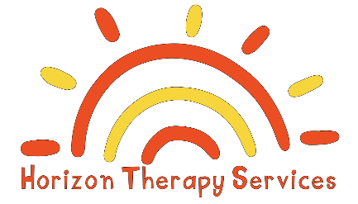

Sick/Illness Policy
To keep the children healthy and at their best, keep your child home if they are not feeling like themselves.
Below are some guidelines on when to keep your child home. They must be free of any of these for 24 hours.
- Vomiting - keep home until child is vomit free for 24 hours.
- Diarrhea - If your child is spending most of their time in the bathroom, has 2 or more loose/watery stools in 24 hours.
- Fever - Children must be fever-free for 24 hours. If your child has a fever of 101°F or higher, please keep him or her home.
- Illness being treated with an antibiotic. Depending on the illness, children cannot return on an antibiotic before 24 hours.
- Rash - A rash may be a sign of many illnesses, such as measles or chicken pox. In infants, an external rash may be a sign that something is going on internally. Please do not bring your child to speech therapy with a rash until the doctor says it is OK to do so.
- Other - if your child appears to have an infectious or contagious condition, i.e. pink eye, head lice etc., you will be asked to take him/her home or to a pediatrician to get checked out. Please do not be offended if your child is too ill to attend therapy and you are asked to take them home.
If your child experiences any of these during speech therapy, we will ask that you take your child home. Please do not be offended if your child is too ill to attend therapy and you are asked to take them home. Please understand that your child’s well-being, as well as the well-being of the employees of Horizon Therapy Services, PLLC and their families are our number one concern.

Parent Signature: __________________________________
Date: _____________________________________

